一 cloudstack api调度流程

我们发往cloudstack的api命令由management端的ApiServlet的processRequest(req, resp)处理，该函数开启一个线程进行处理。对于login和logout命令单独处理，其它命令发往ApiServer组件进行处理

final String response = _apiServer.handleRequest(params, responseType, auditTrailSb);

在ApiServer组件的 handleRequest函数中，通过解析参数 params，构建出 cmdObj对象，剩余参数存入 paramMap，之后进入命令的调度入口函数 queueCommand：

// This is where the command is either serialized, or directly dispatched
response = queueCommand(cmdObj, paramMap);

在ApiServer组件的 queueCommand 函数中，会依据 cmdObj的类型进行不同的调度路径
// Queue command based on Cmd super class:
// BaseCmd: cmd is dispatched to ApiDispatcher, executed, serialized and returned.

// BaseAsyncCmd: cmd is processed and submitted as an AsyncJob, job related info is serialized and returned.

// BaseAsyncCreateCmd: cmd params are processed and create() is called, then same workflow as BaseAsyncCmd.

下面给出DeployVMCmd创建VM命令的类继承结构

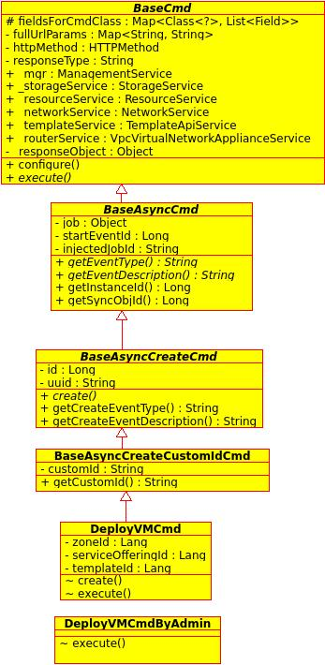

在 queueCommand 函数中，调用逻辑关键代码如下：

if (cmdObj instanceof BaseAsyncCmd) {

if (cmdObj instanceof BaseAsyncCreateCmd) {

_dispatcher.dispatchCreateCmd(createCmd, params);
}
else {
dispatchChainFactory.getStandardDispatchChain().dispatch(new DispatchTask(cmdObj, params));
}

AsyncJobVO job = new AsyncJobVO(...);
job.setDispatcher(_asyncDispatcher.getName());
final long jobId = _asyncMgr.submitAsyncJob(job);

return getBaseAsyncResponse(jobId, asyncCmd);

}
else {

_dispatcher.dispatch(cmdObj, params, false);

return ApiResponseSerializer.toSerializedString(...);
}
上面的调度逻辑涉及了5个类：
ApiDispatcher _dispatcher，
DispatchChainFactory dispatchChainFactory，

ApiAsyncJobDispatcher _asyncDispatcher，
AsyncJobVO job，
AsyncJobManager _asyncMgr，

ApiDispatcher，DispatchChainFactory2个类是用于直接调度cmd对象。
下面是ApiDispatcher的类图

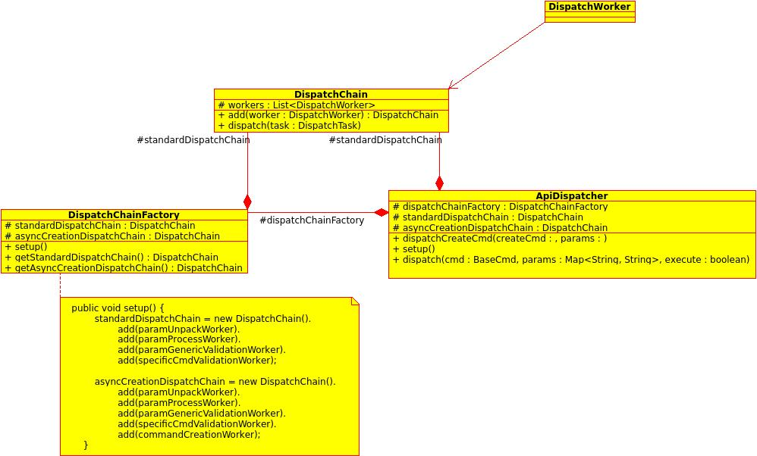

ApiDispatcher的 dispatchCreateCmd(createCmd, params)会执行Cmd对象createCmd 的create()方法。
ApiDispatcher的dispatch(cmdObj, params, false)会执行Cmd对象cmdObj的execute()
方法。此外，在执行cmd对象方法execute()前，会对cmdObj进行判断

if (cmd instanceof BaseAsyncCmd) {

.....

_asyncMgr.syncAsyncJobExecution((AsyncJob)asyncCmd.getJob(), asyncCmd.getSyncObjType(), asyncCmd.getSyncObjId().longValue(), queueSizeLimit);

.....

}

cmd.execute();

异步调度框架的ApiAsyncJobDispatcher采用了ApiDispatcher的dispatch方法来调度cmd对象。

ApiAsyncJobDispatcher，AsyncJobVO，AsyncJobManager 3个类属于异步调度，job管理。

下面是AsyncJob执行流程的顺序图

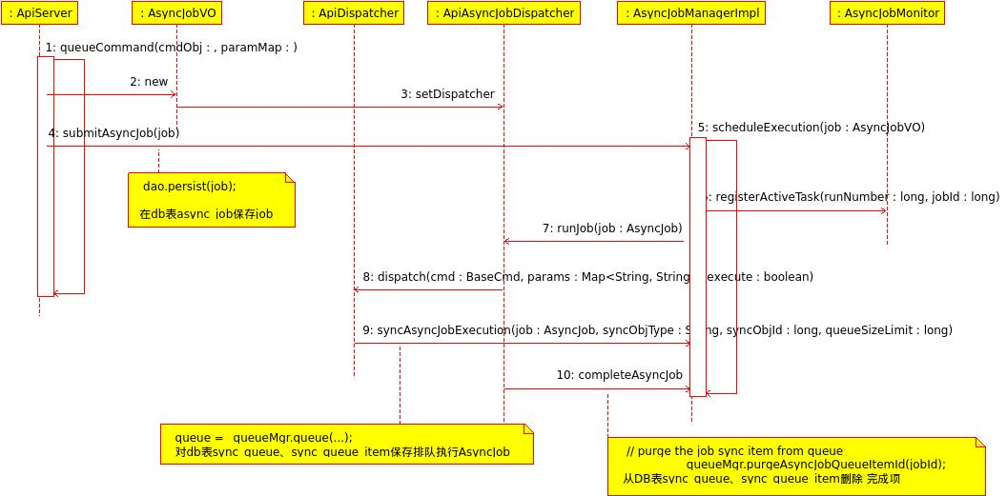

由_asyncMgr.submitAsyncJob(job)开始，调用submitAsyncJob(job, false)函数，该函数将job信息存入到db表async_job中，之后
向messageBus发行submit消息
publishOnEventBus(job, "submit");

调度执行job
scheduleExecution(job, scheduleJobExecutionInContext);

该函数体如下：
private void scheduleExecution(final AsyncJob job, boolean executeInContext) {
Runnable runnable = getExecutorRunnable(job);
if (executeInContext) {
runnable.run();
} else {
if (job.getDispatcher() == null || job.getDispatcher().equalsIgnoreCase("ApiAsyncJobDispatcher"))
_apiJobExecutor.submit(runnable);
else
_workerJobExecutor.submit(runnable);
}
}

传入的 scheduleJobExecutionInContext为false，并且job的Dispatcher为 ApiAsyncJobDispatcher，最终会把runnable放入_apiJobExecutor线程池中运行。

跟入getExecutorRunnable(job)会跟踪job的执行流程
关键代码
_jobMonitor.registerActiveTask(runNumber, job.getId());
对job执行情况进行监视。

关键代码

if ((getAndResetPendingSignals(job) & AsyncJob.Constants.SIGNAL_MASK_WAKEUP) != 0) {
AsyncJobDispatcher jobDispatcher = getWakeupDispatcher(job);
if (jobDispatcher != null) {
jobDispatcher.runJob(job);
}
...
} else {
AsyncJobDispatcher jobDispatcher = getDispatcher(job.getDispatcher());
if (jobDispatcher != null) {
jobDispatcher.runJob(job);
}
}

job无论是通过Signals被激活还是正常的执行，都会先获取job的 jobDispatcher调度器，执行调度器
jobDispatcher.runJob(job)的runJob(job)方法。

Api命令的job调度器为 ApiAsyncJobDispatcher，进入 ApiAsyncJobDispatcher的runJob(job)方法：
在 ApiAsyncJobDispatcher的runJob(final AsyncJob job)方法中，关键代码为

.....
Class<?> cmdClass = Class.forName(job.getCmd());
cmdObj = (BaseAsyncCmd)cmdClass.newInstance();
cmdObj = ComponentContext.inject(cmdObj);
cmdObj.configure();
cmdObj.setJob(job);

.....

// dispatch could ultimately queue the job
_dispatcher.dispatch(cmdObj, params, true);

// serialize this to the async job table
_asyncJobMgr.completeAsyncJob(job.getId(), JobInfo.Status.SUCCEEDED, 0, ApiSerializerHelper.toSerializedString(cmdObj.getResponseObject()));

......
由job构建cmdObj对象，通过ApiDispatcher的dispatch方法来调度cmd对象，调度执行完成后对db async job 相关表进行更改。前面提到过，ApiDispatcher的dispatch方法在执行cmd对象方法execute()前，如果cmd对象为 BaseAsyncCmd的子类，会调用AsyncJobManagerImpl的

syncAsyncJobExecution(AsyncJob job, String syncObjType, long syncObjId, long queueSizeLimit)方法。

该方法将待执行job的信息插入db的表sync_queue和sync_queue_item中。
之后执行cmd对象的execute()方法。

调度完后，通过AsyncJobManagerImpl的 completeAsyncJob(...)方法对db表async_job，sync_queue_item和sync_queue修改，完成的job从sync_queue_item和sync_queue删除。

